**Day 4 Assignment | Dec 02 2024**

**Job runs**

**Q.1.1. Run job on Load tutorial**

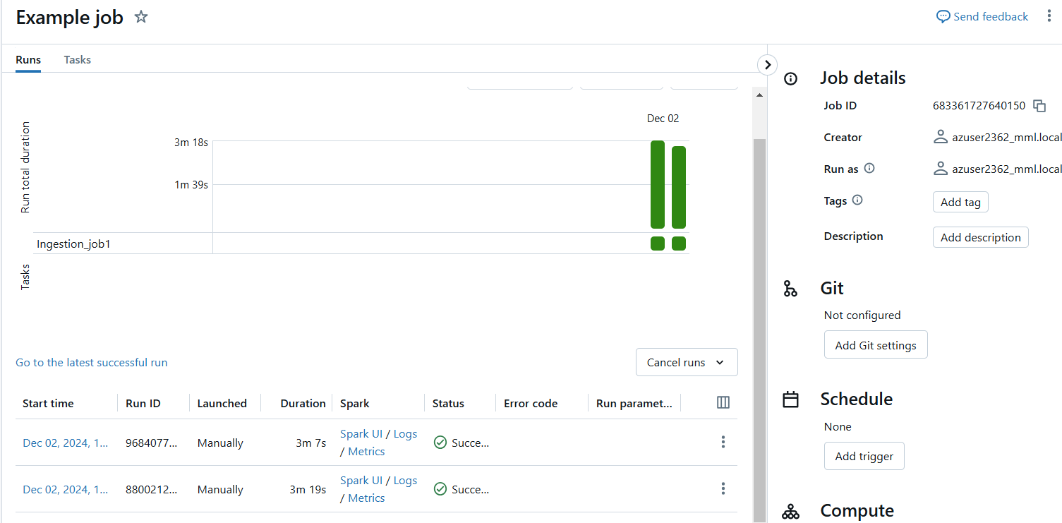



**Q.1.2. Run job on Create job using existing notebook in local system**

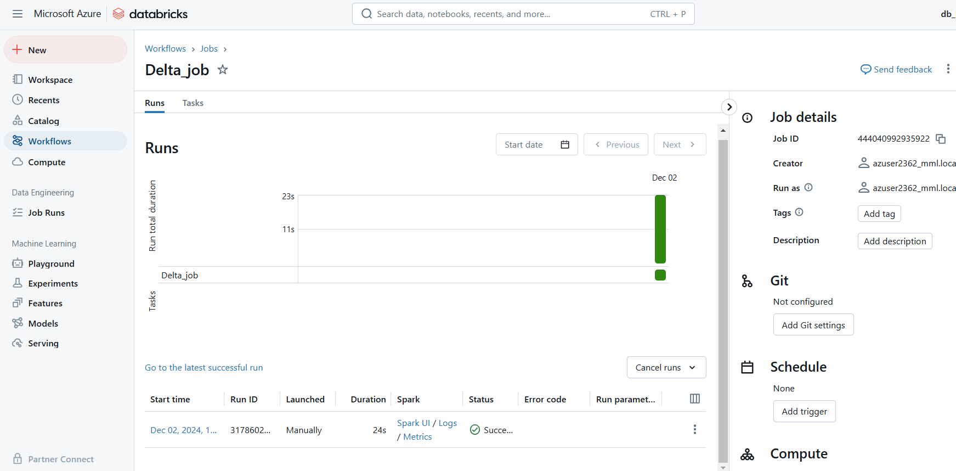



**Q. 2.1. Create azure blob storage account**

Step1: open azure storage accounts in workspace

Step2:Create a new storage account giving the following specifications

Location East US

Storage account name datastoresinadb-----------🡪Give a unique name

Primary service Azure Blob Storage or Azure Data Lake Storage Gen 2

Performance Standard

Replication Locally-redundant storage (LRS)

**Disable** the hierarchical name space

Step3:click create and wait until deployment is complete

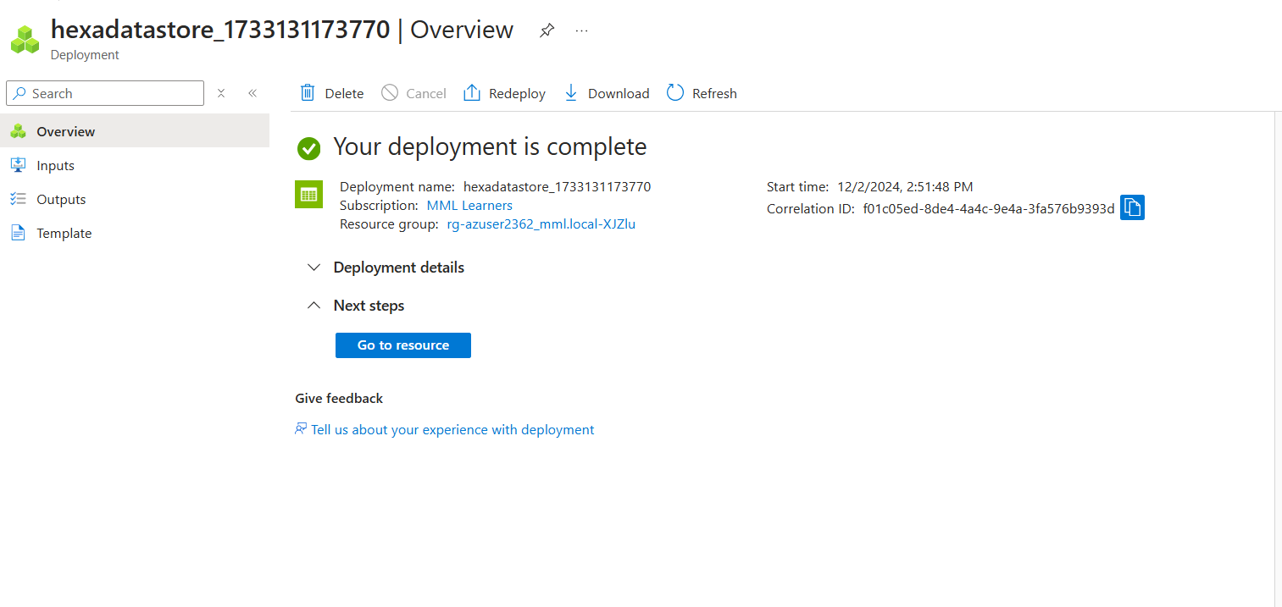

We can view the specifications by clicking on go to resource.

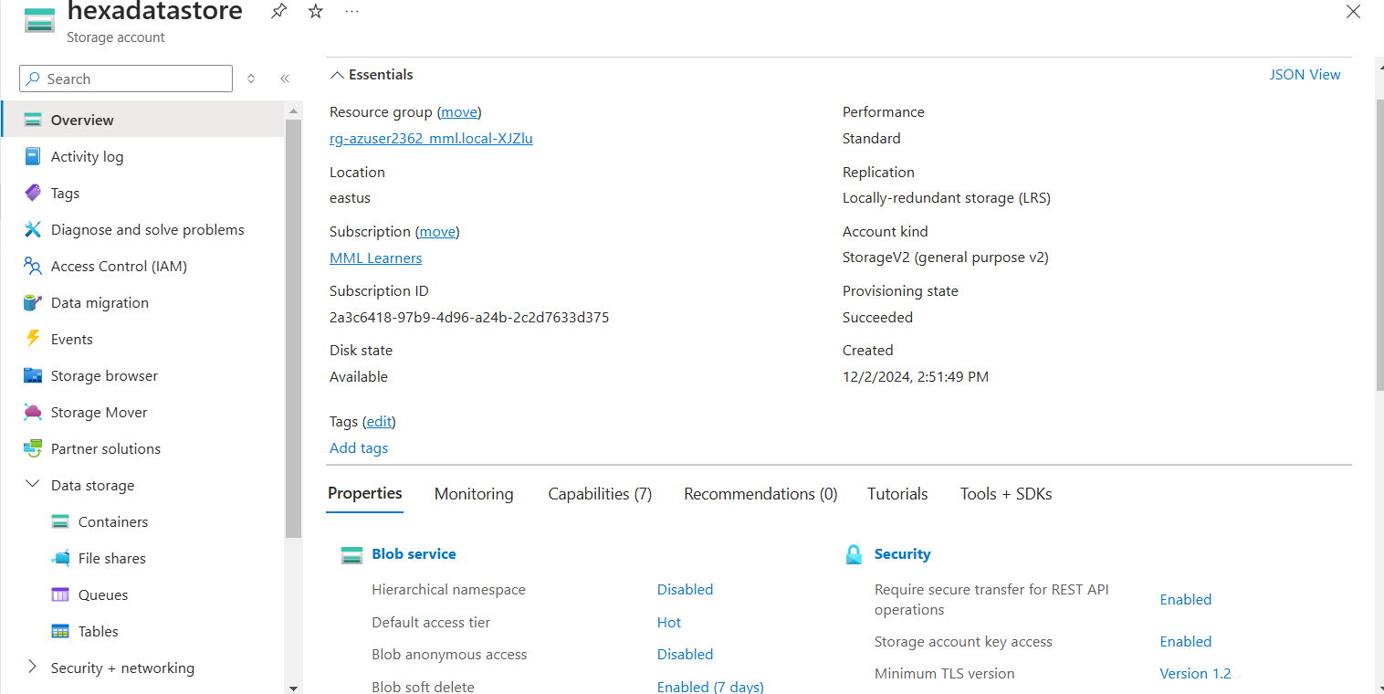

Step6: Click on data storage/containers. Create new container by giving it a name.

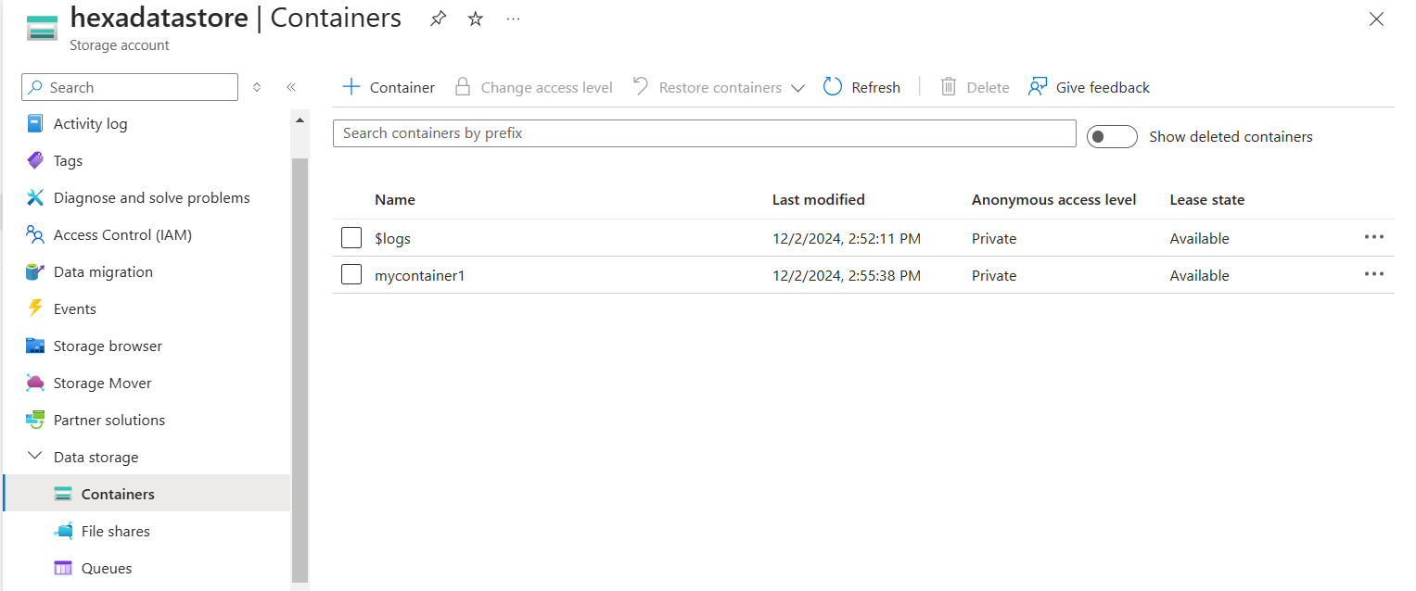

Step 7: Add any file in the container.It is safe to enable “override file if already exists”

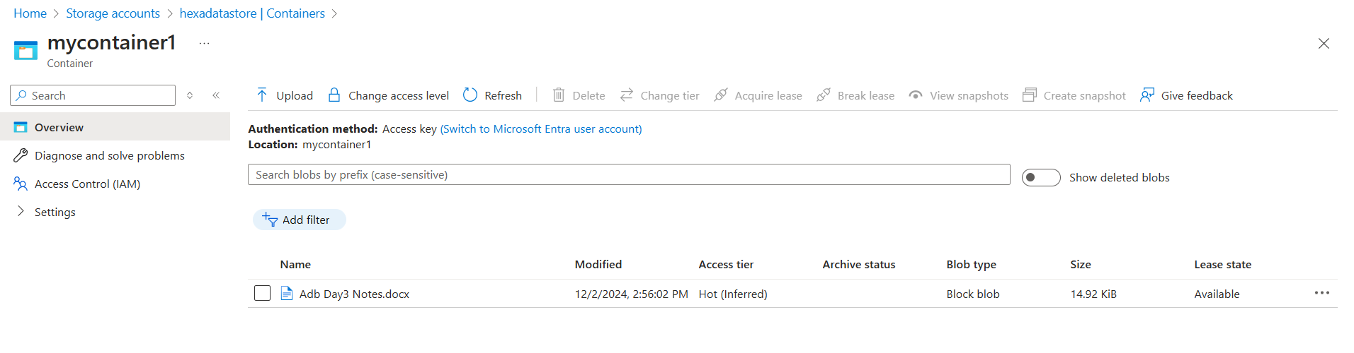

**Q. 2.2. Create Azure blob data lake storage account Gen2**

Step1: open azure storage accounts in workspace

Step2:Create a new storage account giving the following specifications

Location East US

Storage account name datastoresinadb-----------🡪Give a unique name

Primary service Azure Blob Storage or Azure Data Lake Storage Gen 2

Performance Standard

Replication Locally-redundant storage (LRS)

**Enable** the hierarchical name space

Step3:click create and wait until deployment is complete

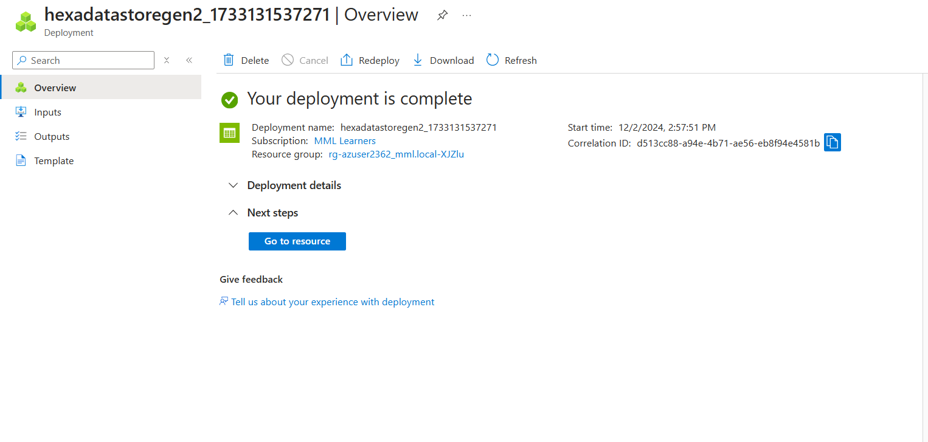

Step4:By clicking “go to resource” we can view the overview

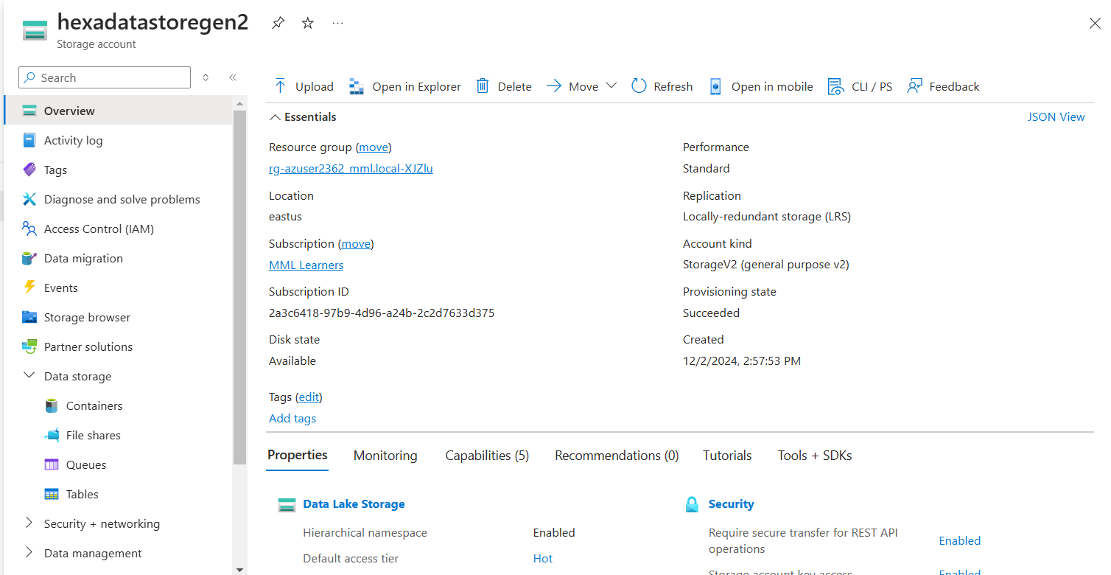

Click Data storage/containers.Create a new container.we can either directly add the file or create the directory and then ad files in the specified directory

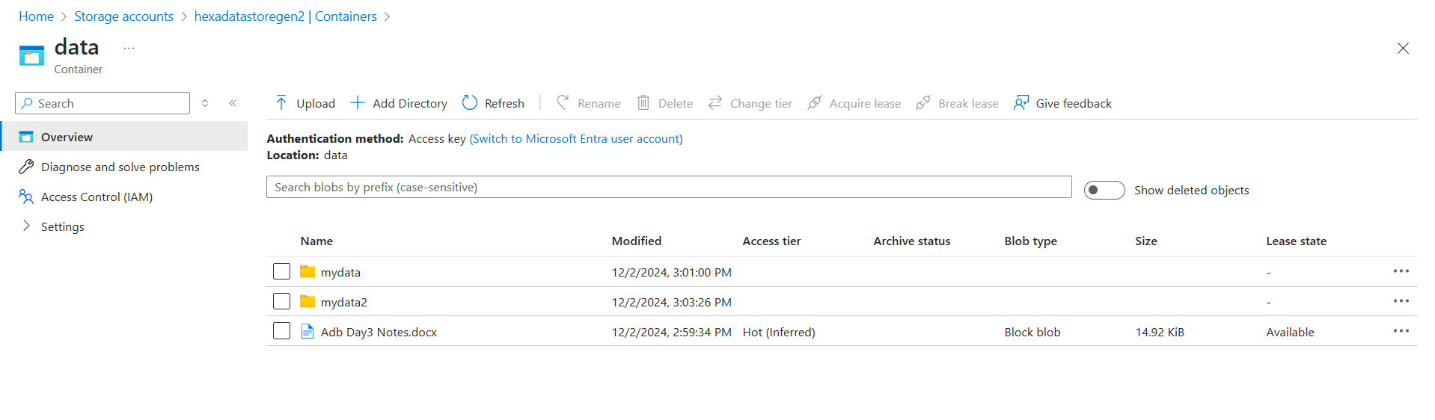

Viewing both of the storage accounts created.

